Systems Analysis and Design
Phase 1 Activity Diagram
D24130668
Nompumelelo Khumalo

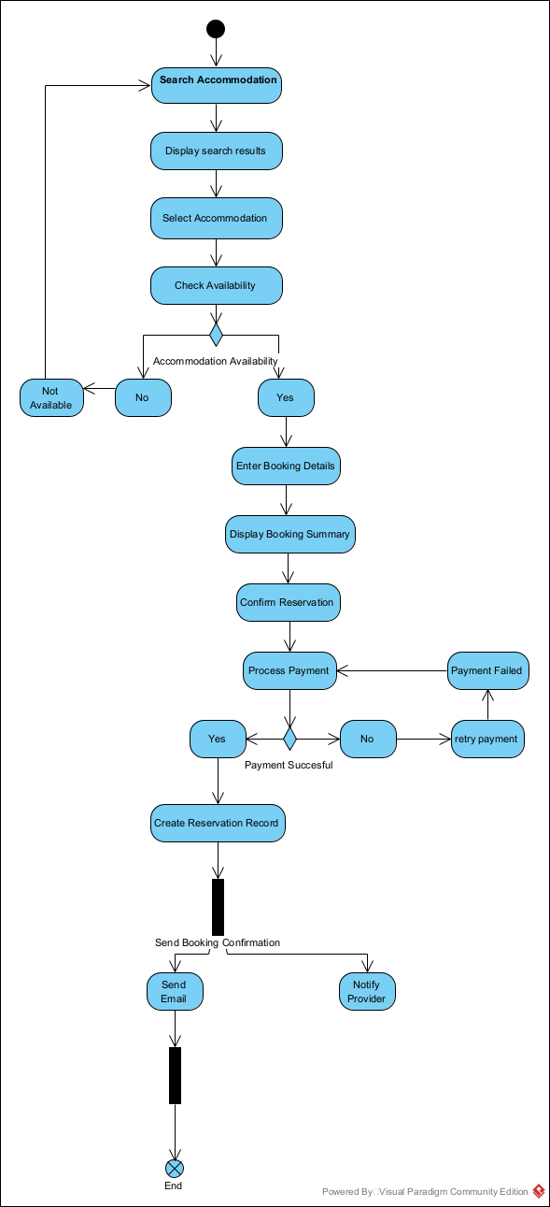
My UML Activity Diagram design is based on "Create Reservation" use case, it has a sufficient level of interaction between actor and application also it aligns with my use case narrative. The diagram structure is above and the work flow is below:

Steps I followed for my activity diagram:
- From the beginning there is search for accommodation
- Display search results
- System retrieves and displays available properties

- Select Accommodation
- Customer chooses a property

- Check availability
- System verifies if the property is available
- Decision node 1: is accommodation available? Yes/No therefore system displays message.
- System displays message: Accommodation Not Available- Customer returns to Search Accommodation.

- Enter booking details
- Customer enters number of guests, check-in date, check-out date

- Display booking summary
- System shows price and reservation details.

- Confirm Reservation
- Customer confirms booking

- Process Payment
- System sends payment request to payment Gateway.
- Decision node 2. Payment failed.

- Create reservation record
- System stores booking information

- Send booking confirmation
System sends confirmation: E-mail to customer, notification to accommodation provider.

END NODE. The reservation process is completed.

